Preliminary Research Spark Living Labs

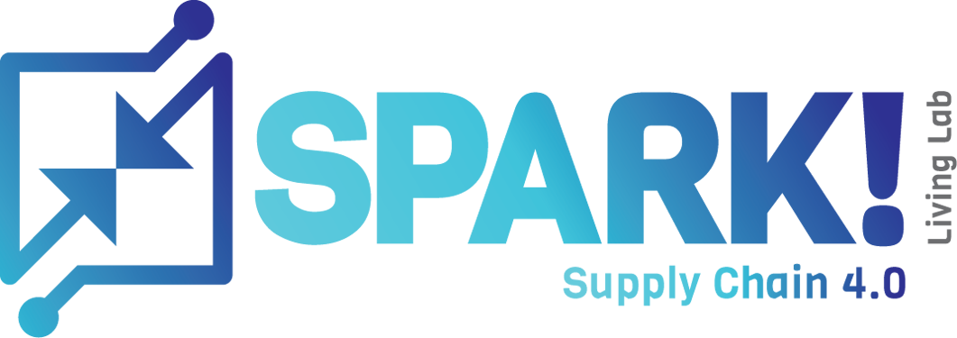

**Students:**  
Kaan Erdem, Jocelyn Maufrand, and Genaro Hüner.

**Project Minor:** Supply Chain Engineering

***Report version:*** v1.1

Inhoud

1. Introduction 2

1.1 Schoolside of the project 2

2. Problem Analysis 3

2.1 The context 3

2.2 The reason for the project 3

2.2.1 For whom is the project urgent/ needed? 3

3. The Project/ Task 4

3.1 Projectkader 4

3.2 Doelstelling van het onderzoek 4

3.3 Centrale vraag (of vragen) 4

3.4 Randvoorwaarden voor het onderzoek 4

3.5 Afbakeningen 4

3.5.1 Afbakening van de interventie 4

4. Conceptual approach 5

4.1. Theoretisch kader 5

4.2 Conceptual model 6

4.2.1 Onderzoeksontwerp 6

5. Onderzoeksmodel 7

5.1 Onderzoeksmethoden en de onderbouwing 7

5.2 Overzicht tussen- en eindresultaten 7

5.3 Projectcontrolling 7

5.3.1 Time 7

5.3.2 Money 7

5.3.3 Quality 7

5.3.4 Information 7

5.3.5 Organisatie 8

# 1. Introduction

## 1.1 School side of the project

This school project is conducted by Kaan Erdem, Genaro Hüner and Jocelyn Maufrand who all of them studied for this semester at Windesheim University of Applied Sciences. The purpose of this project is to build up a benchmark about new technology used in Supply Chain by the companies. The module which this project belongs is Project Supply Chain Engineering (EDPSCE). The internship period for the academic year 2021/2022 started on 7 September 2021 and will end in January 2022. This agreement is that two days per week are spent on the project assignment. For the project assignment, we must eventually hand in a short report.

**Organisation:**

Sparklivinglab is a structure which regroup students, teachers, and manufacturers to find what kind of new technology could be use in logistic and Supply Chain today and in the future. This research is divided on six parts:

* Track and Trace: Insight into reliable and accurate delivery times, origin and certification at product level is the holy grail of the logistics sector.
* Progress integration: Improve procure-to-pay and order-to-cash processes by using reliable and accurate digital transport and export documents.
* Digital twins: A digital product passport with product information to be used by the entire chain offers all kinds of possibilities for sustainability.
* Checking shelf life and quality: The real-time monitoring and execution of an SLA around conditioned (e.g., refrigerated) transport is still limited by the available information.
* Secure data exchange: The secure exchange of reliable information is crucial. While maintaining a level playing field for all participating parties, open and inclusive.
* Paper progresses: Paper documents play a major role, especially in export. How can these be digitized without the risk of fraud? And what does this mean for automatic execution?

(Spark Living Lab, n.d.)

# 2. Problem Analysis

## 2.1 The context

Spark Living Labs is a co-creation of business, research and education which helps companies improve their supply chain by implementing different kinds of data driven technologies. They can also provide a great help in optimising logistics or circular economy all of which a lot of companies are struggling with nowadays. Spark Living Labs ensures that the company gets the right implementation of technology and at the same time still be as productive or even more productive than before.

## 2.2 The reason for the project

This research project is part of the research programme Sustainable Living Labs, which is co-financed by the Dutch Research Council (NWO), the Ministry of Infrastructure and Water Management, Taskforce for Applied Research (SIA) and the Top Sector Logistics. The main goal is to explore the application of data sharing technologies in supply chain and logistics to support advance the circular economy.

### 2.2.1 For whom is the project urgent/ needed?

#### Vision on the subject

Spark Living Labs sees that the demand on circular economy and well data driven technologies is high, to make sure that companies join along in this journey, they have set up physical hubs where it is possible to experiment with data driven technologies and IoT (Internet of Things) and prepare for future working environment. Besides Spark, the companies that actually join the project benefit from it as well, since the government have set a goal for 2050 to be emission free and sustainable. If the project rolls out well than there's three parties that benefit from this project.

# 3. The Project/ Task

The goal of this chapter is to define the project on a technical basis. This means defining the problem, goals, and the prerequisites.

## 3.1 Project framework

Spark Living Lab is a group of independent parties working together to improve the processes within the supply chain and logistics. They are aiming for the use of modern technologies for different underdeveloped or rapidly developing companies. This includes pre-research and advising futuristic technologies and methods for their clients within different sectors.

For this project the goals it to create a visual-/tool for the Lab to work with. The need for this tool has become important for Spark Living Lab due to the rapid growth within the supply chain technologies. Moreover, the urgency for this visual-/tool will also be making the different technologies visible for the clients in a comprehensive way.

## 3.2 Goals of the research

Goal of this visual-/tool will also be making the different technologies visible for the clients in a comprehensive way. Besides that, the goal is to do research into the used cases for the data driven technology so that they have more information regarding the technologies that could be advised by Spark to their clients, these technologies mainly concern the big topics of data driven technologies such as Blockchain, Internet of Things, Artificial Intelligence and Big Data. The focus could also shift over to some other related data driven technologies.

## 3.3 Central question(s)

Central question :

* How can Spark Living Lab link the problems to the data sharing technologies and give comprehensive/ effective advice about the available technological opportunities for their client’s operations?

Sub questions:

* What are the multiple different data sharing technologies?
* Which ones are the most impactful?
* What are the distinguishing criteria of those technologies?
* What are maturity levels of the data sharing technologies?

## 3.4 Research prerequisites

In this sub part the goal is to define the limitations and the requirements from the Spark Living Lab. The limitations and the requirements are listed as followed:

* The visual-/tool has to be clear and easy to comprehend.
* The visual-/tool has to be easily updatable for when new information needs to be added.
* The visual-/tool has to be able to be used by different cases by other groups.
* The process should not require any financial investment or expenses.
* Waterproof visual-/tool, highly trustable to give advice to external parties.

## 3.5 Demarcation

### 3.5.1 Demarcation of the Interventioncyclus

In this chapter, the project group will be defining the limitation of the process. In other words, which steps will the project group execute during these twenty weeks of period. Looking at the model down below, the group will be executing the problem identification, diagnosis, intervention plan, and intervention phase. The evaluation phase will not be executed fully due to the limitations of time.

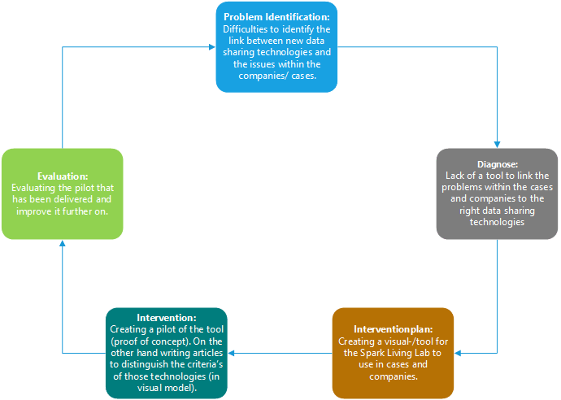

Figure Interventioncyclus

# 4. Conceptual approach

## 4.1. Theoretisch kader

In this paragraph all the theoretical models that the project group is aiming to use during their end report is defined. Those theoretical subjects are not the only theories that will be used, there can be other fitting theoretical models be discovered by the group and used in the report later.

### SWOT-analysis:

To define the weaknesses, the strengths, risk, and the opportunities of different data sharing technologies. By defining those using the SWOT-analysis, the main goal is to be able to categorise the subjects in a certain way to make the differences easier to compare.

Figure SWOT-Analysis (Vlieger, 2013)

### DESTEP/PESTEL:

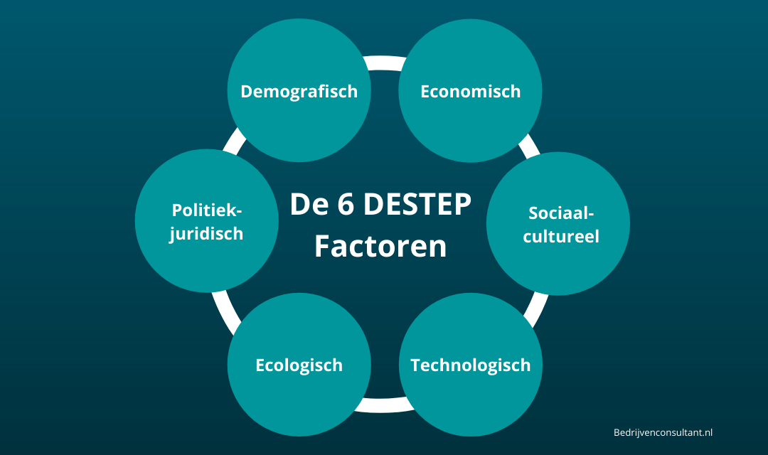To describe the environment. is a framework or tool used by marketers to analyse and monitor the macro-environmental (external marketing environment) factors that have an impact on an organisation. The result of which is used to identify threats and weaknesses which are used in a SWOT analysis.

Figure DESTEP- Model (Bedrijvenconsultant.nl)

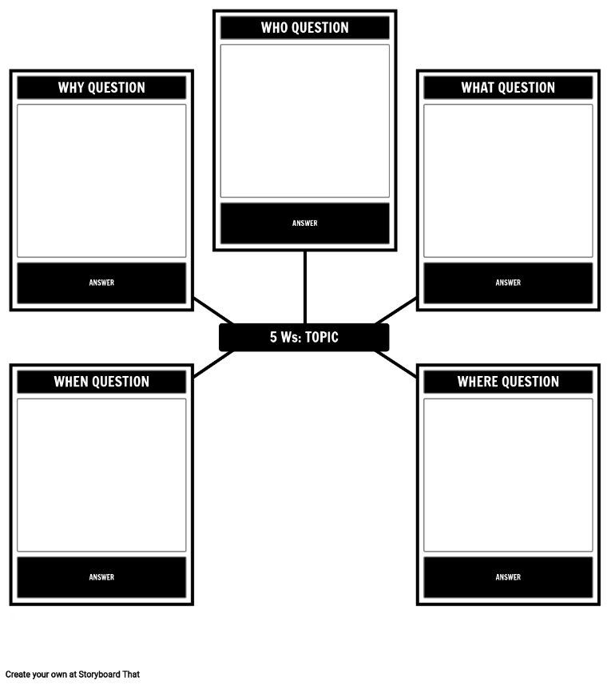

Figure 4 5 W's Model (Windesheim - Consultancy Skills)

5 W’s:

Those are the questions whose answers are considered basic and enable to start to solve a problem or gather information about a topic. By using 5 W’s analysis, we can just gather information about or focus on our data sharing technology without move away from the subject.

### Ishikawa diagram:

Is a diagram that show the potential causes of a specific event. By using Ishikawa analysis, can define the shareholder, materials, tools, or digital technologies which are in interaction with our data sharing technologies, the way to these technologies.

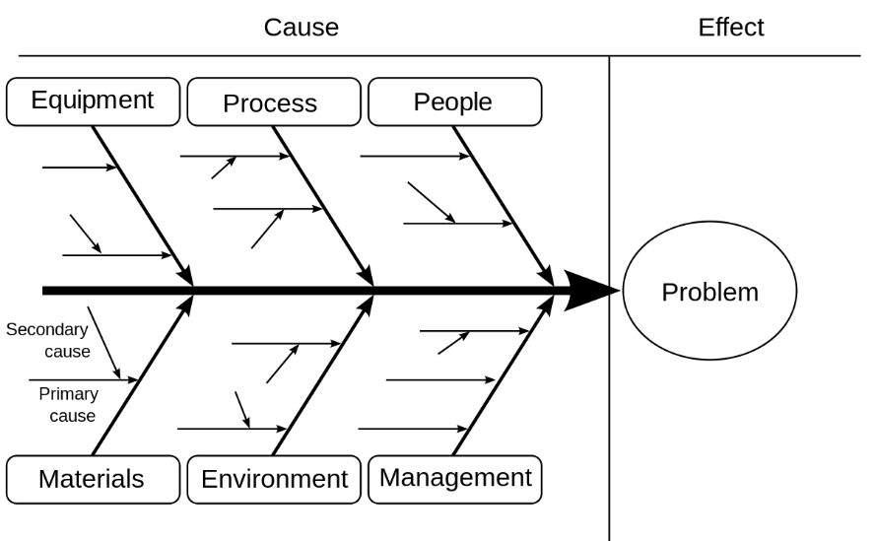

Figure (Ishikawa, n.d.)

Projectmanagement triangle (Quality, Time, Cost):

Divided by three variables that determine the of the quality of the project: scope, cost and time. This triangle shows how these variables are linked. Indeed, if one of these is modified, the others must be adjusted to keep the triangle connected. For our project, this kind of analysis enable to frame a data sharing technology that we study: How long will it be available (tomorrow, 5 year,…)? How much does it cost to install this one? What is the quality this technology? Is it safe?

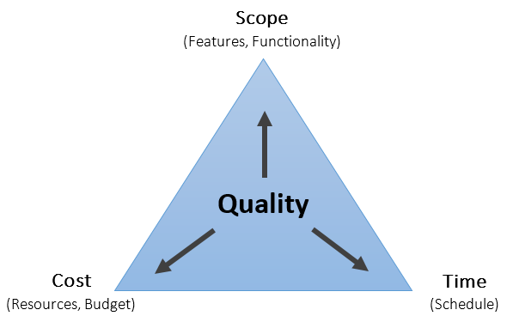

Figure 6 Projectmanagement Triangle

### Gartner’s Maturity Model:

Figure Gartners Maturity Model (oreilly, 2017)

In order to see the availability of different data sharing technologies, we aim to use the maturity model of gartner. This model indicates what phase the current technology is finding place. By defining the place in the maturity matrix the goal is to make a priority list for the companies to see which technology is available and in which phase it is ready to be used within their situation.

## 4.2 Conceptual model

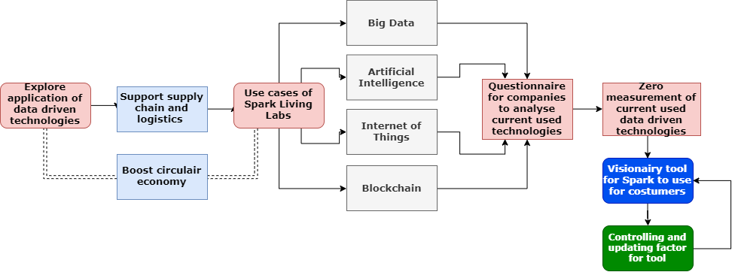

Figure Conceptual Model

# 5. Researchmodel

## 5.1 Research methods and explanation

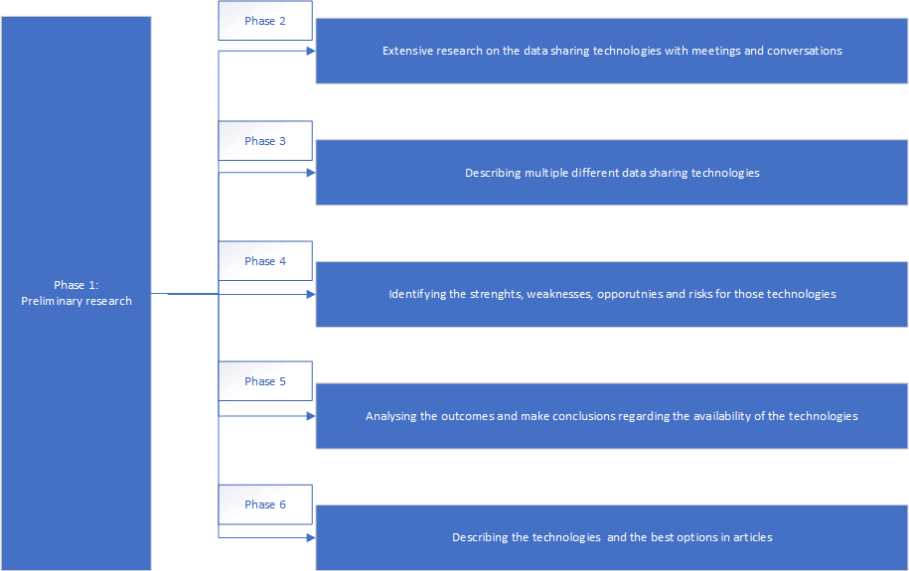

Figure Research Phases

#### Phase 1

At first, we must realise a preliminary phase to frame our assignment. This phase includes identify the problems, the companies, putting the scope for the project and the stakeholders.

#### Phase 2

At the second, we are going to make extensive research more specifically by setting up meetings with the companies, students, external parties that are using data sharing technologies.

#### Phase 3

Describing the data sharing technologies in depth to make it more comprehensive for the analysis later in the report.

#### Phase 4

Then, the plan is to name the strength, the weakness, the opportunities, and the risks for each data sharing technologies.

#### Phase 5

Analysing the outcomes from the previous chapters and comparing the results with used or real cases. Making conclusion out of the different results and chapters to specify the most viable technology in the close and far future.

#### Phase 6

Describing the technologies and the best options that are available in short but informative articles. To make it easier for SparkLivingLab to present the technologies to their customers and other connections.

## 5.2 Vision on the end- and sub results

The results that we are aiming to get during the project are as followed:

* Describing and identifying the most important data sharing technologies that exist.
* Identifying the importance and the risks of each focussed technology.
* Writing short but strong articles about those technologies.
* Satisfying the company and the school with the delivered reports.

## 5.3 Project controlling

## 5.3.1 Time

There are 20 weeks available to finish our research and deliver the final report. The project started at September 7th and shall finish in February.

## 5.3.2 Money

There hasn’t been any discussion regarding the money that is being required to execute the research. Looking at our project description and goals, we can say that we do not need any funding at this moment.

## 5.3.3 Quality

The preliminary research will be built in a way that the answers to the questions regarding the problems and the required information will be structurally put in the final report.

## 5.3.4 Information

Think of the communication within the project, and to the outside.Within the project it is clear that new technological trends have arisen, as a result of which the working methods of external and internal parties may be different than at present. That is why various parties are involved to discuss and clarify the interests of the stakeholders. Within the project, there is often consultation with the company (SparkLivingLab) and the various groups within the company to obtain the necessary information.

## 5.3.5 Organisation

In this sub part, the organigram of the different parties within Spark Living Lab has been defined. Open the file below to see the attachment.



# 6. Gantt Chart

Open the file below to see the Gantt- Chart



# Bibliografie

*Ishikawa*. (n.d.). Retrieved from Sixsigma: https://www.sixsigma.nl/artikelen/ishikawa

oreilly. (2017, October 23). *A. Gartner Maturity Model for Data and Analytics*. Retrieved from www.oreilly.com: https://www.oreilly.com/library/view/streaming-change-data/9781492032526/app01.html

Spark Living Lab. (n.d.). *Spark Living Lab*. Retrieved from Spark Living Lab: sparklivinglab.nl/

Vlieger, R. D. (2013, 03 13). *SWOT analysis*. Retrieved from Call The One: https://www.calltheone.com/en/consultants/swot-analysis